Monte Carlo DCF Enterprise Value Analysis
Oshkosh Corporation (OSK) | 50,000 simulations | Five-year forecast
All monetary values are US$ millions unless otherwise stated.

1. Executive Summary
This project applies Monte Carlo simulation to a discounted cash flow framework to estimate a probability distribution for the enterprise value of Oshkosh Corporation rather than relying on a single deterministic valuation. The simulation varies key operating and valuation assumptions across 50,000 trials and compares the resulting model-implied enterprise values with the current enterprise value of $9,060 million.
Measure | Model result | Interpretation
Mean enterprise value | $9,027.50m | 0.36% below current EV
Median enterprise value | $8,986.06m | 0.82% below current EV
5th percentile | $5,750.28m | Severe downside scenario
95th percentile | $12,453.60m | Strong upside scenario
Probability EV > $9,060m | 48.652% | Upside probability is slightly below 50%
Probability EV ≤ $9,060m | 51.348% | Downside probability is slightly above 50%
Overall conclusion. The central valuation is close to the current enterprise value, indicating that OSK appears broadly fairly valued under the simulated assumptions. The distribution is wide, however, with a 5th-to-95th percentile range of approximately $5.75 billion to $12.45 billion. This demonstrates meaningful valuation uncertainty and shows that the investment conclusion depends heavily on discount-rate and terminal-value assumptions.
Model-review warning: the current Python code treats the simulated net working capital ratio (approximately 16.6%–17.7%) as a dollar change and subtracts only about 0.17 from annual FCFF. The ratio should instead be converted into a working-capital balance and the year-on-year change should be deducted. The reported valuation distribution should therefore be treated as a preliminary model output until this formula is corrected and the simulation is rerun.

2. Project Objective
The objective is to estimate a defensible range of possible enterprise values for OSK by combining a five-year unlevered DCF with Monte Carlo simulation. The approach recognises that sales growth, profitability, capital expenditure, tax, working capital, the weighted average cost of capital, and perpetual growth are uncertain rather than fixed.
- Produce a valuation distribution instead of one point estimate.
- Measure downside, central, and upside valuation outcomes using percentiles.
- Estimate the probability that model-implied enterprise value exceeds the current enterprise value.
- Identify the assumptions that have the strongest relationship with enterprise value.

3. Historical Basis and Model Inputs
The simulation inputs were calibrated primarily from the historical financial analysis in the accompanying workbook. OSK reported 2024 sales of $10,755.5 million, operating income of $1,010.7 million, depreciation and amortisation of $200.1 million, capital expenditure of $232.0 million, and operating net working capital of $1,786.5 million. Historical analysis also showed a 2024 EBIT margin of 9.397%, capex equal to 2.157% of sales, and operating working capital equal to 16.610% of sales. These figures provide the starting point and ranges used in the simulation.
Input | Distribution / range | Economic role | Implementation
Sales growth | Year-specific triangular ranges; modes decline from 12% to 7% | Drives forecast revenue | Independently simulated by year
EBIT margin | Triangular: 4.495% / 7.458% / 9.397% | Determines operating profit | One draw held constant across five years
WACC | Triangular: 8% / 9% / 11% | Discounts FCFF and terminal value | One draw held constant across five years
Perpetual growth | Triangular: 1.5% / 2.5% / 3.1% | Drives terminal value | One draw per simulation
Capex / sales | Triangular: 2.157% / 3.000% / 3.913% | Cash reinvestment requirement | One draw held constant across five years
Tax rate | Triangular: 21.0% / 23.3% / 26.0% | Converts EBIT to NOPAT | One draw held constant across five years
Operating NWC / sales | Triangular: 16.6% / 16.7% / 17.7% | Working-capital investment | Requires formula correction
D&A | $200.1m grown with cumulative sales | Non-cash add-back | Scales with revenue growth

4. Methodology
For each of 50,000 trials, the model generates a five-year financial path and calculates enterprise value using the following sequence:
- Forecast sales by compounding the simulated annual sales-growth rates from the 2024 revenue base.
- Estimate EBIT as forecast sales multiplied by the simulated EBIT margin.
- Calculate NOPAT as EBIT × (1 − tax rate).
- Estimate FCFF as NOPAT + depreciation and amortisation − capital expenditure − change in net working capital.
- Discount each annual FCFF by the simulated WACC.
- Calculate terminal value using the Gordon growth model: Terminal FCFF ÷ (WACC − perpetual growth).
- Add the present value of forecast-period FCFF and terminal value to obtain model-implied enterprise value.
Core equation: Enterprise Value = Σ[FCFFₜ ÷ (1 + WACC)ᵗ] + [Terminal Value ÷ (1 + WACC)⁵].

5. Simulation Results
The simulated distribution is approximately bell-shaped around the central valuation, with a visible right tail. The median of $8,986.06 million is slightly lower than the mean of $9,027.50 million, consistent with modest positive skew from high-value terminal scenarios. The histogram marks the 5th, 50th, and 95th percentiles at $5,750.28 million, $8,986.06 million, and $12,453.60 million, respectively.
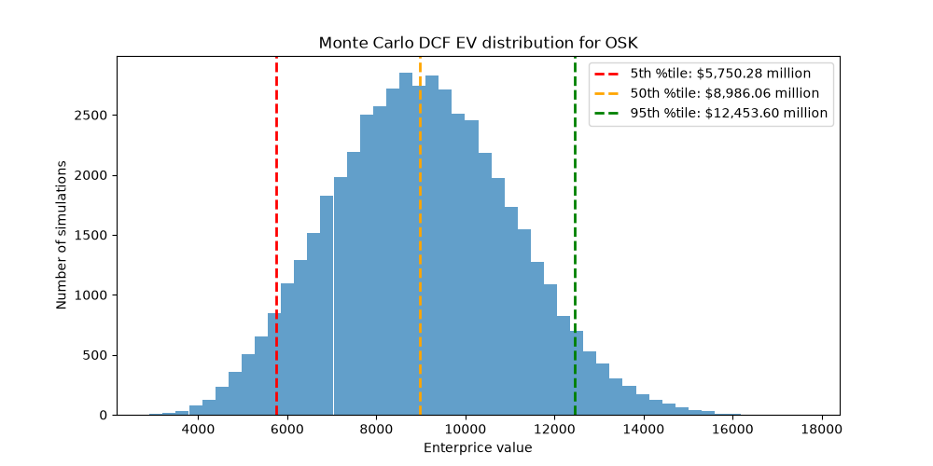
Figure 1. Monte Carlo DCF enterprise-value distribution for OSK. The red, orange, and green dashed lines represent the 5th, 50th, and 95th percentiles.

Scenario interpretation
Scenario definition | Enterprise-value range | Interpretation
Lower third / conservative | Below $8,089.05m | Weak operating or valuation assumptions; below current EV
Middle third / base | $8,089.05m–$9,890.45m | Central range spanning the current EV of $9,060m
Upper third / optimistic | Above $9,890.45m | Favourable operating performance and/or valuation assumptions
90% probability interval | $5,750.28m–$12,453.60m | Broad uncertainty range between 5th and 95th percentiles
Market comparison. The current enterprise value of $9,060 million is $32.50 million above the simulation mean and $73.94 million above the median. The probability of model-implied enterprise value exceeding the current value is 48.652%, while the probability of being equal to or below the current value is 51.348%. The model therefore does not indicate a clear valuation advantage at the current EV; instead, it suggests a nearly balanced risk-reward profile.

6. Sensitivity Analysis

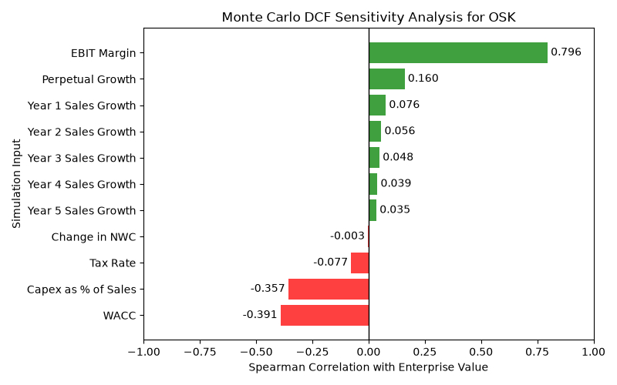
The Monte Carlo sensitivity analysis shows that EBIT margin is the dominant valuation driver, with a strong positive correlation of 0.796 with enterprise value. WACC and capital expenditure as a percentage of sales are the largest negative drivers, with correlations of -0.391 and -0.357, respectively. Perpetual growth has a moderate positive impact of 0.160, while individual annual sales-growth assumptions have relatively limited effects. These results indicate that OSK’s valuation depends primarily on operating profitability, discount rates and capital expenditure assumptions.

7. Investment Interpretation
- Central valuation: Mean and median enterprise values are close to the current EV, suggesting that OSK is approximately fairly valued under the modelled assumptions.
- Downside risk: The 5th-percentile EV of $5.75 billion is about 36.5% below the current EV, showing material downside under adverse combinations of operating performance and valuation assumptions.
- Upside potential: The 95th-percentile EV of $12.45 billion is about 37.5% above the current EV, indicating meaningful upside if growth, profitability, and terminal assumptions are favourable.
- Decision quality: Because the probability of exceeding current EV is only 48.652%, the simulation does not provide a strong standalone buy signal.
- Key value driver: WACC is the strongest measured driver, highlighting the importance of capital-market conditions and discount-rate selection.
- Use in practice: The output is most useful as a valuation-risk framework for investment screening, negotiation ranges, scenario planning, and identifying assumptions requiring further due diligence. 9. Conclusion
The Monte Carlo DCF provides a more informative valuation framework than a single-case DCF because it quantifies both the central estimate and the dispersion of possible outcomes. Based on the reported run, OSK has a mean model-implied enterprise value of $9.03 billion and a median of $8.99 billion, both close to the current EV of $9.06 billion. The 48.652% probability of exceeding current EV suggests no decisive undervaluation signal, while the wide 5th-to-95th percentile range demonstrates substantial uncertainty. The preliminary investment conclusion is therefore neutral: OSK may offer upside under favourable assumptions, but the valuation does not provide a clear margin of safety. This conclusion should be revisited after correcting the working-capital treatment and expanding the sensitivity analysis.

Appendix: Correct Working-Capital Logic
The intended treatment is to forecast the operating NWC balance as a percentage of sales and deduct only the annual increase in that balance from FCFF:
Forecast NWCₜ = Forecast Salesₜ × NWC-to-Sales Ratio
Change in NWC₁ = Forecast NWC₁ − Initial NWC
Change in NWCₜ = Forecast NWCₜ − Forecast NWCₜ₋₁
Using initial operating NWC of approximately $1,786.5 million from the workbook would align the forecast with the historical NWC-to-sales ratio and prevent FCFF from being overstated.

